Johnny Li

EEL3111C

Tuesday P.10-11

Lab 9-Write Up

Introduction

The goal of this lab is to explore was to see how filters work in a circuit. Such applications include filtering low or high signals either passively or actively with a trigger. Filters are mainly implemented to ensure that certain signals go through while others do not to ensure a specific result or to protect the components.

Discussion

9.6.1 Practical Implementations

Table 1: Table of experimental 3 dB frequencies and their associated percent errors when compared to the pre-lab.

|  |  |  |
| --- | --- | --- |
| Circuit Design- Physical | 3 dB Frequencies (Hz) | Percent Error (%) |
| 2. Simple RC lowpass filter | 15,110 Hz | 5.06% |
| 3. Simple RC highpass filter | 1052.0 Hz | 0.85% |
| 4. Active RC lowpass filter | 1630.0 Hz | 2.42% |
| 5. Active RC highpass filter | 494.9 Hz | 2.61% |

1. Figure 1: The output and the measure of the 3-dB frequency from Section 9.5.1 - Item 4 in the lab manual with the number of samples to 1000.

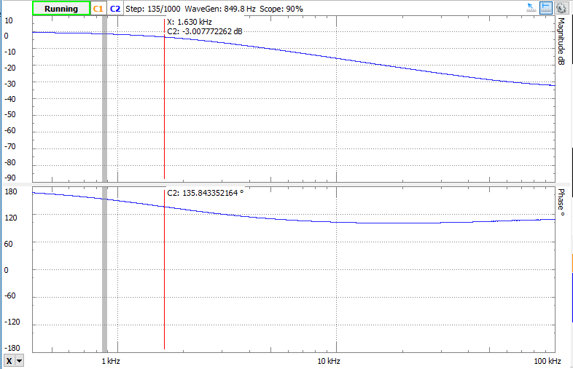

This is an active RC lowpass filter used to appropriately placed capacitor in conjunction with a typical inverting amplifier configuration. The filter passes signals with a low frequency while high frequencies signals are cutoff where is only initiates based on an external trigger response. The percent error is less than the standard 5% which means the result in a reasonable outcome and such errors can be attributed to the component variation

2. Figure 2: The output and the measure of the 3-dB frequency from Section 9.5.1 - Item 2 in the lab manual.

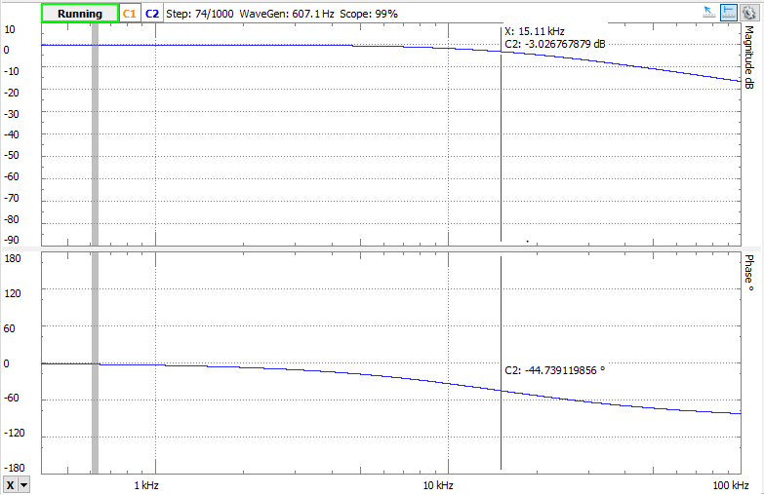

This is a simply RC lowpass filter where low frequencies are passed while high frequencies are attenuate. This is a passive filter thus no active elements are required power. The percent error is around the standard 5% which can be attributed to the component variation.

3. Figure 3: The output and the measure of the 3-dB frequency from Section 9.5.1 - Item 3 in the lab manual.

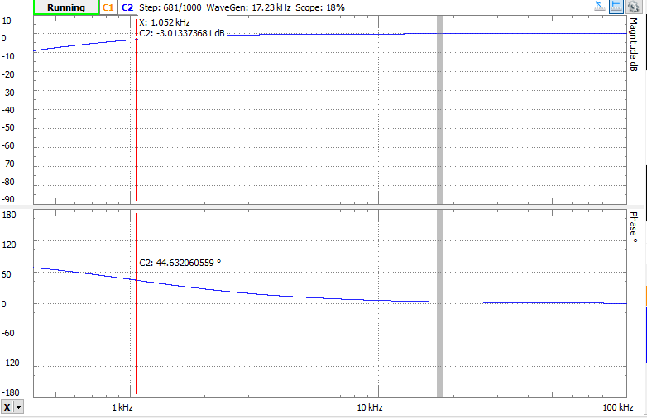

This is a simply RC highpass filter where high frequencies are passed while low frequencies are attenuate. This is a passive filter thus no active elements are required power. The percent error is less than the 1% which means that such an error is irrelevant to the outcome.

4. Figure 4: The output and the measure of the 3-dB frequency from Section 9.5.1 - Item 5 in the lab manual with the amplitude set to 100 mV from 1 V and the top to 30-dB.

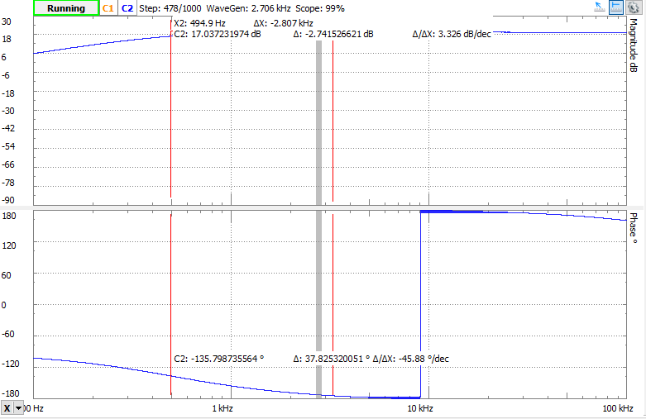

This is an active RC highpass filter used to appropriately placed capacitor in conjunction with a typical inverting amplifier configuration. The filter passes signals with a high frequency while low frequencies signals are cutoff where is only initiates based on an external trigger response. The percent error is less than the standard 5% which means the result in a reasonable outcome and such errors can be attributed to the component variation

Besides component variation, other effects that continue to shift the 3-dB frequency from its ideal value is the variations in an alternating current that is used to generate the values. Also, the numbers of samples determine the accurately of the results.

The advantages of active filter include the uses of op amp, it can produce a high gain, this has a high voltage output with a low voltage input. In addition, there is no loading problem and greater flexibility in control of the system. The disadvantages of active filter are that a power supply is required and there are constrains with the op amp gain bandwidth, op amp slew rate, and components, require more components.

The advantages of passive filter are that there no power supply required, can handle large currents and high voltages, all op amp constrains, require less components and thus cheaper, and ignore. The disadvantages of passive filter include no power or voltage gain possible and must be designed with consideration to input and output loading.

Conclusion:

In conclusion, the lab focused on filters and some of their many functions. Some are implemented in the physical circuits build or in the simulations. The use of highpass and lowpass filters in active and passive designs were specifically taught in this lab.